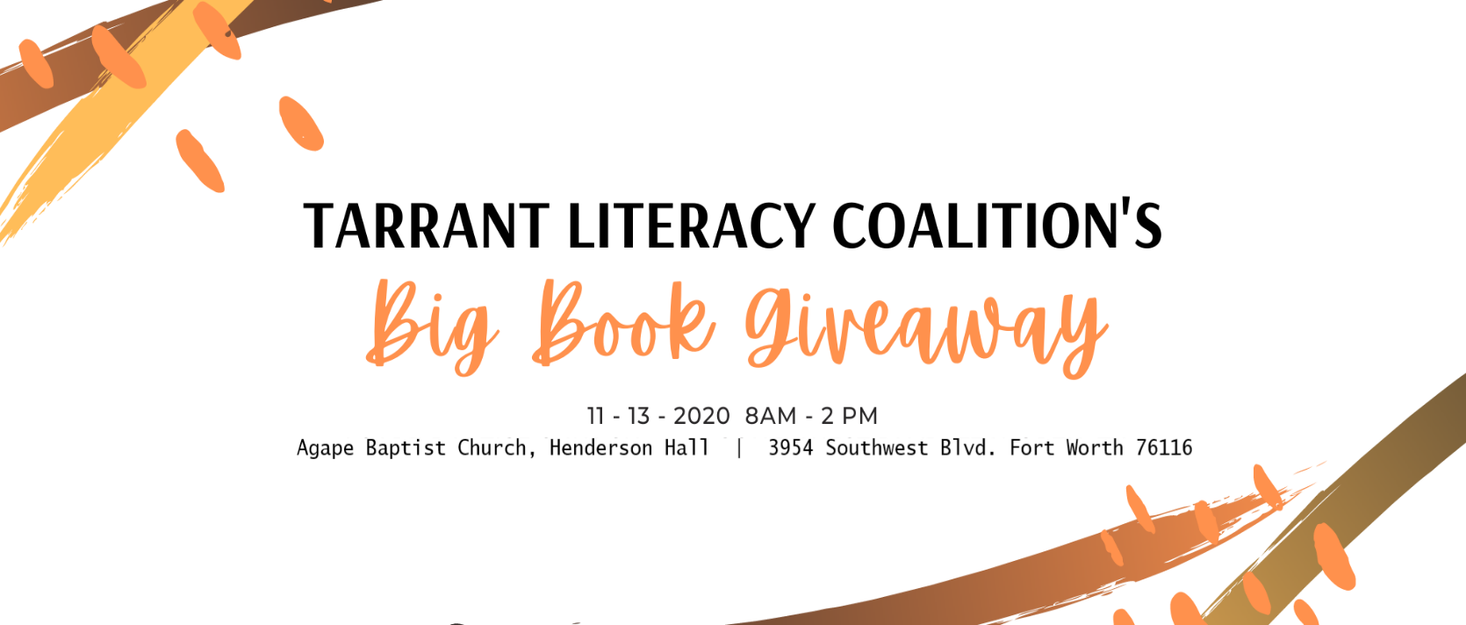When the Coalition first began in 2009, we made it a priority to get books and other resources into the hands of those who need them the most! It’s a tradition that continues every November with the Big Book Giveaway. This year, we’ll be holding the giveaway on Friday, November 13, from 8:00 AM – 2:00 PM. We’re opening our doors and bookshelves to everyone: find supplemental curricula to fill in gaps in lesson plans, pick up something for your student(s) or grab a guilty pleasure read or audiobook for yourself! The first 20 guests will receive a Half Price Books tote bag and for the third year we will also be collecting new pairs of socks for the Friends Helping Friends Community Sock Drive supporting Presbyterian Night Shelter in Fort Worth – bring a pair or bundle to receive a special thank you gift. Join us for hot chocolate, cider, baked goods and books in November!
